Internship - I Report on
Front-end Development

Submitted in Partial fulfillment for the award of degree of Bachelor of Technology in Electronics & Communication Department

Rajiv Gandhi Proudyogiki Vishwavidyalaya, Bhopal (M.P.)

Submitted By:
JNCT, Bhopal
Pavan Gir - 0131EC221022

Under the Guidance of Professor
Amit Sawaskade
DEPARTMENT OF
Electronics & Communication



Jai Narain College of Technology, Bhopal
Approved by AICTE New Delhi & Govt. of M.P.
Affiliated to Rajiv Gandhi Proudyogiki Vishwavidyalaya, Bhopal (M.P.) Session: 2023 – 2024
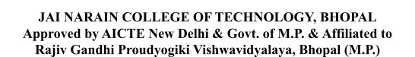

DEPARTMENT OF

ELECTRONICS & COMMUNICATION

CERTIFICATE
This is to certify that the work embodied in this Internship, Report entitled as “Front-end Development” being Submitted by Pavan Gir – 0131EC221022 in partial fulfillment of the requirement for the award of “Bachelor of Technology” in Electronics & Communication discipline to Rajiv Gandhi Proudyogiki Vishwavidyalaya, Bhopal (M.P.) during the academic year 2023-2024 is a record of bonafide piece of work, carried out under my supervision and guidance in the Department of Electronics & Communication, Jai Narain College of Technology, Bhopal.
N
J
CT, Bhopal

Approved by
Guided by  Prof. Amit Sawaskade | Head of Department  Prof. Amit Sawaskade
Dean, Academics  Dr. Vivek Dubey | Principal  Dr. Netra Pal Singh

DEPARTMENT OF

ELECTRONICS & COMMUNOCATION

CERTIFICATE OF APPROVAL

This Internship “Front-end Development” being submitted by Pavan Gir - 0131EC221022 has been examined by me & hereby approve for the partial fulfillment of the requirement for the award of “Bachelor of Technology in Electronics & Communication”, for which it has been submitted. It is understood that by this approval the undersigned do not necessarily endorse or approve any statement made, opinion expressed or conclusion drawn therein, but the Project only for the purpose for which it has been submitted.
JNCT, Bhopal

INTERNAL EXAMINER  Date: | EXTERNAL EXAMINER  Date:

CANDIDATE DECLARATION

I hereby declare that the Internship presented in the report entitled as “Front-end Development” submitted in the partial fulfillment of the requirements for the award of the degree of Bachelor of Technology in Front-end Development of Jai Narain College of Technology, Bhopal is an authentic record of our own work.
JNCT, Bhopal
I have not submitted the part and partial of this report for the award of any other degree or diploma.

Pavan Gir - 0131EC221022
Date
This is to certify that the above statement made by the candidates is correct to the best of my knowledge.
Guided By:
Prof. Amit Sawaskade

ACKNOWLEDGMENT

I am heartily thankful to the Jai Narain College of Technology for providing us all the facilities and infrastructure to take our work to the final stage.
It is the constant supervision, moral support and proper guidance of our respected Principal Prof. Dr. Netra Pal Singh and Dean Academics Prof. Dr. Vivek Dubey, who motivated throughout the work. We express a deep sense of gratitude and respect to our learned guide Prof. Amit Sawaskade, Professor in the Program of Front-end Development, during all phases of my work. Without his enthusiasm and encouragement this dissertation would not have been completed. His valuable knowledge and innovative ideas helped us to take the work to the final stage. He has timely suggested actions and procedures to follow for which we are really grateful and thankful to him.
JNCT, Bhopal
I express our gratitude to Prof. Amit Sawaskade Head of Front-end Development . Department for providing all the facilities available in the department for his continuous support, advice, and encouragement during this work and also to help to extend our knowledge and proper guidelines.
Constant help, moral and financial support of our loving parents motivated us to complete the work. I express our heartfelt thanks to all our family members for their cooperation.
I really admire the fond support of our class-mates for their cooperation and constant help. It gives immense pleasure to acknowledge the encouragement and support extended by them. Last but not the least we are extremely thankful to all who have directly or indirectly helped us for the completion of the work.

Pavan Gir – 0131EC221022

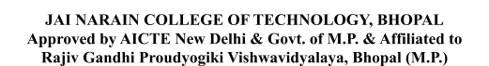

Abstract

A major part of my internship involved working on multiple real-world projects across different domains. I developed e-commerce websites, portfolio websites, and other frontend interfaces, which helped me understand user experience design, project workflow, and the importance of clean, maintainable code. These projects also strengthened my skills in problem-solving, debugging, and optimizing performance.

Additionally, I had the opportunity to collaborate, understand client requirements, and follow modern development practices. Overall, this internship played a significant role in shaping my skills as a frontend developer. It not only boosted my confidence in working with advanced frameworks but also prepared me for future professional challenges in the field of web development.

This internship provided me with a valuable and immersive experience in the field of frontend web development, allowing me to strengthen both my technical skills and my understanding of modern web technologies. Throughout the internship period, I worked with a wide range of tools and frameworks, including HTML, CSS, Tailwind CSS, JavaScript, GSAP, and React.js. Learning and applying these technologies enabled me to build responsive, interactive, and visually appealing user interfaces. I gained hands-on experience in structuring webpages, styling components, implementing animations, and developing reusable UI elements using component-driven architecture.

INDEX
JNCT-Bhopal

S. No. | Table of Contents | Page No.
1 | - Introduction  - Background: Briefly describe the organization and its industry.  - Objective of the Internship: State the purpose and goals of the internship.  - Organization Profile  - Internship Certificate | 2
2 | - Internship Activities  - Description of Tasks and Responsibilities you were assigned  - Projects/Modules Undertaken: Describe any specific projects you worked on.  - Tools and Technologies Used: List any software, tools, or technologies you used during the internship.  - Skills Acquired: Mention any new skills you learned.  - Professional Skills**: What professional skills did you develop?  - Technical Skills: Any technical skills or knowledge gained.  - Personal Growth: Reflect on how the internship contributed to your personal development. | 4
3 | - Challenges and Solutions  - Challenges Faced: Describe any difficulties you encountered.  - Solutions and Strategies: How did you overcome these challenges? | 6
4 | Conclusion  Summarize your overall experience, key learnings, and how the internship has influenced your career goals. | 7
5 | Appendices  Include any additional material, such as charts, graphs, or detailed descriptions of projects. | 8
6 | References  List any books, articles, websites, or other resources you referred to during your internship. | 9

Front-end Development:

- Introduction
  - Background: Briefly describe the organization and its industry.

The internship was completed at ABMN Postulate Pvt. Ltd., a leading software development company specializing in web and mobile application development, cloud computing, and artificial intelligence solutions. Established in 2022, the organization provides innovative IT services to clients in healthcare, education, and e-commerce sectors. The company follows modern development methodologies like Data Science, Full Stack Development and Java, ensuring efficient and quality product delivery.

  - Objective of the Internship: State the purpose and goals of the internship.

The main objective of the internship was to gain hands-on industry experience and apply the theoretical concepts learned in the classroom to real-world software development. Specific goals included:
JNCT-Bhopal
- Understanding software project workflows and team collaboration.

- Enhancing programming and problem-solving skills.

- Learning about modern development tools and technologies used in the industry.

  - Organization Profile

ABMN Postulate Pvt. Ltd. is a leading software development and IT services company established in 2022. The organization specializes in web application development, mobile app solutions, cloud computing, artificial intelligence, and data analytics.
Headquartered in Bhopal Madhya Pradesh, the company serves clients across various domains including education, healthcare, finance, and e-commerce. It follows modern development methodologies like Agile and DevOps, ensuring timely delivery of high-quality software solutions.
The company’s mission is to provide innovative and reliable digital solutions that empower businesses to achieve digital transformation. The team consists of highly skilled software engineers, designers, and data analysts who work collaboratively to meet client expectations.

JNCT-Bhopal

  - Internship Certificate

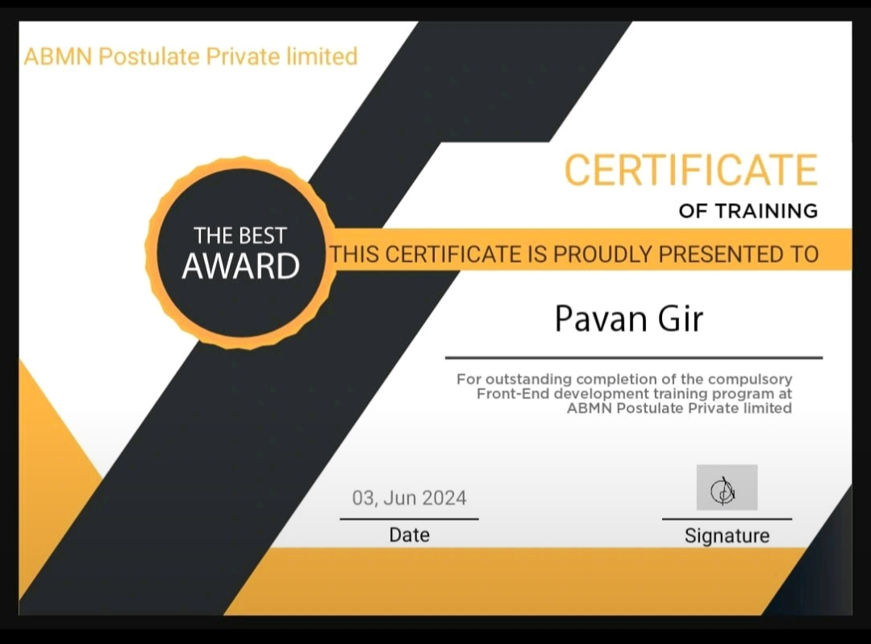

Internship Activities

Description of Tasks and Responsibilities
During the internship, I was assigned to the Software Development Team, where I assisted in designing, coding, testing, and documenting application modules. My responsibilities included writing clean and efficient code, participating in daily team discussions, fixing bugs, and maintaining version control using Git. I also contributed to preparing project reports and testing documentation under the guidance of my mentor.

Projects/Modules Undertaken
JNCT-Bhopal
I worked on a project titled “E-Commerce Websites”, aimed at UI design components, responsive webpages and utilized JavaScript for interactivity and functionality.
The modules developed and tested during the internship included:

- User Authentication Module – For secure login and role-based access.

- Attendance Recording Module – For capturing daily check-in and check-out data.

Tools and Technologies Used
- Programming Languages: HTML, CSS, JavaScript, GSAP
- Frameworks: React JS
- Database: MySQL
- Version Control: Git and GitHub
- IDE: MySQL, Visual Studio Code
- Other Tools: Postman for API testing, Trello for task tracking

Skills Acquired
    - Professional Skills
      - Improved teamwork and communication through collaboration with developers and mentors.

      - Developed project planning and documentation abilities.

      - Learned to work efficiently in a professional Agile environment with daily reporting and code reviews.

    - Technical Skills
JNCT-Bhopal

      - Gained proficiency in backend development using React JS .

      - Acquired knowledge of database connectivity and RESTful API design.

      - Enhanced debugging, code optimization, and testing skills.

    - Personal Growth

      - Learned to manage time effectively and work under deadlines.

      - Improved problem-solving and analytical thinking skills.

      - Built self-confidence, adaptability, and responsibility in a workplace environment.

Challenges and Solutions

  - Challenges Faced: Describe any difficulties you encountered.

During the internship, I encountered a few challenges, especially in the initial phase. Understanding the project structure and workflow of a professional development environment was initially difficult. Configuring the React JS framework and database connectivity also posed technical issues. Additionally, managing multiple tasks within tight deadlines and collaborating effectively with team members required adjustment to a fast-paced work environment.
JNCT-Bhopal

  - Solutions and Strategies: How did you overcome these challenges?

To overcome these challenges, I referred to official documentation, online tutorials, and project guidelines to understand the framework better. With the help of my team mentor, I resolved configuration errors and improved debugging techniques. I also adopted better time management strategies, using tools like Trello to track progress and prioritize tasks. Regular discussions with team members helped me improve collaboration and gain confidence in completing assigned work efficiently.

Conclusion

The internship experience at ABMN Postulate Pvt. Ltd. was a valuable and enriching phase of my academic journey. It provided me with practical exposure to real-world software development processes and strengthened my understanding of Web Development.
Through hands-on work, I enhanced my technical expertise, team collaboration, and problem-solving skills. The internship also improved my communication abilities and taught me how to manage projects in a professional setting.
JNCT-Bhopal
Overall, the experience has motivated me to pursue a career in software engineering and Web development, with a strong focus on continuous learning and innovation.

Appendices

- Screenshots of developed project modules.

- Database ER diagram of the Attendance Management System.

- Weekly progress and task reports.
JNCT-Bhopal

References

- ABMN Technologies Pvt. Ltd. – Internal documentation and project manuals.

- Oracle Java Documentation – https://docs.oracle.com

- MySQL Reference Manual – https://dev.mysql.com/doc

- Apna College

- Greek For Greek

- W3Schools Tutorials – https://www.w3schools.com
JNCT-Bhopal

